|  |
| --- |
| **VISVESVARAYA TECHNOLOGICAL UNIVERSITY**  **Jnana Sangama, Belagavi- 590 018** |
| **Description: VTU-Logo-New-Trans.png** |
|  |
| **A**  **Mini Project Report**  **On**  **“Human Resource Database Management System”**  Submitted in partial fulfillment for the award of the Bachelor of Engineering degree  In  Computer Science and Engineering  V Semester  1**5CSL58 – DBMS Laboratory with Mini Project**  For the academic year 2018 – 2019  By |
| **Aastha Gupta 1HK16CS003**  **Fathima Zohra 1HK16CS047**  **Under the guidance of**  **Mrs.Amreen Khanam &**  **Mrs. Manjula H.T**  **Assistant Professor, Department of Computer Science and Engineering**  **December 2018**  **HKBKCE Logo with out KSMF**  **Department of Computer Science & Engineering**  **HKBK COLLEGE *of* ENGINEERING**  **(Approved by AICTE & Affiliated to VTU)**  **22/1, Nagawara, Arabic College Post, Bangalore-45, Karnataka**  **Email: info@hkbk.edu.in URL: www.hkbk.edu.in**  **2018 - 2019** |
|  |
|  |
|  |

|  |  |  |
| --- | --- | --- |
| _____________________ | _____________________ | _____________________ |
| Mr./Ms. Name | Prof. Loganathan R. | Dr. Chaitanya Kumar M. V. |
| Coordinator | Head of the Department | Principal |

|  |
| --- |
|  |
|  |

**Prof.Amreen Khanam Prof.Manjula H T Dr. Loganathan R**

External Viva

Name of the Examiners Signature with Date

1.

2.

.

|  |  |  |
| --- | --- | --- |
| _____________________ |  | _____________________ |
| Mrs. Manjula H. T |  | Dr. Loganathan R |
| Guide |  | Professor &HOD |

|  |  |
| --- | --- |
| External Viva | |
| Name of the Examiners | Signature with Date |
| 1. _______________________________ |  |
| 1. _______________________________ | ______________________________ |

|  |  |
| --- | --- |
|  | **HKBK COLLEGE *of* ENGINEERING**  Nagawara, Bangalore -5600 47  Approved by AICTE & Affiliated to VTU |

**Department of Computer Science and Engineering**

**Certificate**

Certified that the Project Work entitled **“Human Resource Database Management System”,** carried out by **Aastha Gupta (1HK16CS003) and Fathima Zohra (1HK16CS047)** bonafide students of **HKBK COLLEGE *of* ENGINEERING**, in partial fulfillment for the award of **Bachelor of Engineering** in **Computer Science and Engineering** of the **Visvesvaraya Technological University**, Belgavi, during the year 2018–19. It is certified that all corrections/suggestions indicated for Internal Assessment have been incorporated in the report deposited in the departmental library. The project report has been approved as it satisfies the academic requirements in respect of **15CSL58–DBMS Laboratory with Mini Project** prescribed for the said Degree.

**ACKNOWLEDGEMENT**

We are grateful to the Chairman, **Mr. C.M. Ibrahim** and the Director **Mr. Faiz Mohammed C.M.** for having provided us with excellent facilities in the college during our course.

We are indebted to the Principal, for facilitating a congenial academic environment in the college.

We are grateful to **Dr. Loganathan R, HOD, Dept of CSE** for his kind support, guidance and motivation during the course of this project work.

We would like to thank our guide, **Mrs. Amreen Khanam & Mrs.Manjula H.T** and all the staff members of **Computer Science and Engineering Department** and our friends who have directly or indirectly helped us with valuable suggestions in the successful completion of this project.

**Aastha Gupta 1HK16CS003**

**Fathima Zohra 1HK16CS047**

**ABSTRACT**

The System Human Resource Database Management System creates software that stores and manages all the data needed to describe the personal and their framework within an organization .It includes definition of various levels of hierarchy in an organization, the description of every department functioning in the organization and the overall employ database which integrates elements in all the afore mentioned. It has database administration that has access to the entire database, in regards with viewing and update of information. The exclusive right is implemented using authorized access. Also viewing all data and editing of personal data can be done by HR. The data can be accessed, manipulated and retrieved very easily. The interface has been made very friendly. The data is well protected for use and the data processing i,e result of query functions has been made very quick and efficient.

# **TABLE OF CONTENTS**

Acknowledgment i

Abstract ii

## **CHAPTER 1. INTRODUCTION**

1.1 Introduction 1

1.2 Problem Statement 1

1.3 Proposed solution 1

1.4 Objectives 2

1.5 Outcomes of the Project 2

## **CHAPTER 2. REQUIREMENT ANALYSIS**

2.1 Initial Investigation 4

2.2 Information Gathering 4

2.3 Feasibility Study 4

2.4 Existing System 5

2.5 Proposed System 5

2.6 Advantages of proposed system 6

## **CHAPTER 3. SYSTEM REQUIREMENT SPECIFICATION**

3.1 Functional Requirements 7

3.2 Non-Functional Requirements 7

## **CHAPTER 4. SYSTEM DESIGN**

4.1 System Architecture 8

4.2 ER diagram 9

4.3 Schema diagram 10

4.4 Flow Chart 11

**CHAPTER 5. IMPLEMENTATION**

5.1 Tools and Languages Used 14

5.2 Module

5.2.1 Module 1 - login 14

5.2.2 Module 2 – main menu 16

5.2.3 Module 3 - insert 17

5.2.4 Module 4 – search

5.2.5 Module 5 – delete 18

5.2.5 Module 6 - update 20

**CHAPTER 6. TESTING**

6.1 Test case 1: Home Page 22

6.2 Test case 2: Admin login 22

6.4 Test case 4: Admin login 22

6.5 Test case 5: Insert 23

6.6 Test case 6: Insert 23

6.7 Test case 7: Delete 23

6.8 Test case 8: Search 24

6.9 Test case 9: Edit 24

**CHAPTER 7. SNAPSHOTS**

7.1 Home Page 25

7.2 login 25

7.3 Main menu 26

7.4 Insert 26

7.5 Delete 28

7.6 Update 29

7.7 Search 30

**CHAPTER 8. CONCLUSION AND FUTURE WORK**

Conclusion and Future Work 31

**References**

**CHAPTER 1**

**INTRODUCTION**

**CHAPTER 1**

**INTRODUCTION**

**1.1 Introduction**

The Project has been developed keeping in view to develop a system that deals with the day to day requirement of an organization and also to enable the organization to come out with an easy to handle system of the Human Resource Management.

The Human Resource Database Management software is very friendly and appealing. The main objective of the system is to maintain and retrieve information about the entire personnel framework of the organizational system. This system is fairly simple in design and implementation. The proposed system is to design a hierarchical framework in terms of positions held. Thus depicting the organizational hierarchy. Update of the structure of the same as well as addition of new elements. We can search for all employees, departments, dependent information etc. is possible which can be department wise, level-wise and other parameter based search enabled. There is computerized payroll generation, manipulation and management. It is a easy management of databases of various sections covering key aspects.

**1.2 Problem Statement**

* Slow process of the organization’s human resource. In the past recording keeping was done on paper and with spreadsheets.
* No proper security of the employee’s information as well as the organization’s information.
* Difficulty in monitoring their daily records.
* Slow retrieval of data.
* Poor data storage.
* Unsecured data.

**1.3 Proposed Solution**

The proposed system provides detail general information about the employee along with Educational, Certification, Skill and project details.

It enhances the HR management in adding, viewing and updating employees’ details and generates various reports regarding employees’ skill and experience. Improved manual system is another solution for the improvement of the system. Also it promises very less or no paper work and also provides help administrate and electronically. Information can be retrieved very easily.

**1.4 Objectives.**

Human Resource Information System is a systematic way of storing data and information for each individual for each individual employee to aid planning, decision making and submitting of returns and reports to the external agencies. It is an online solution for the data entry and tracking of a company’s human resources department information, payroll, management and accounting An effective HRS provides information on just about anything the company needs to track and analyze about employees, former employees and applicants.

**Thus in a nutshell, an HRS serves the following functions:**

* Storing information and data of each individual employee
* Providing a basis for planning, decision making, controlling and other human resource functions.
* Supplying data and submitting it the organization
* Retrieving data about individual employee.
* Modifying the information related to a particular employee .

**1.5 Outcomes of the project.**

* Contribute to the development, implementation, and evaluation of employee.
* Develop, implement, and evaluate organizational development strategies aimed at promoting organizational effectiveness.
* Conduct research, produce reports, and recommend changes in human resources practices.
* The organization can keep the track of the number of employees

Easy and effective maintenance job can be done without having any redundancy

**CHAPTER 2**

**REQUIREMENT ANALYSIS**

**CHAPTER 2**

**REQUIREMENT ANALYSIS**

**2.1 Initial Investigation.**

The need of a software that can maintain the details of the employees working in an organization and also to protect their information lead to the development of this system. Initially, there was only manual system for storing their information. As this is a tedious process an approach towards the computerized data storage lead to the development of this system.

**2.2 Information Gathering.**

There are a series of activities regarding to this section such as analyzing, tracking and utilizing data on project. With the help of google as search browser information was gathered. Need for training that is the administrator has to be well trained for the smooth running of the system

**2.3 Feasibility study.**

Once the problem is clearly understood, the next step is to conduct feasibility study, which is high high-level capsule version of the entered systems and design process. The objective is to determine whether or not the proposed system is feasible.

* **Technical Feasibility**

In technical Feasibility study, one has to test whether the proposed system can be developed using existing technology or not. It is planned to implement

the proposed system using java technology. It is evident that the necessary hardware and software are available for development and implementation of the proposed system. Hence, the solution is technically feasible.

* **Economic Feasibility**

As part of this, the costs and benefits associated with the proposed system compared and the project is economically feasible inly if tangible or intangible benefits outweigh costs. The system development costs will be significant. So the proposed system is economically feasible.

* **Operational Feasibility**

It is a standard that ensures interoperability without stifling competition and innovation among users, to the benefit of the public both in terms of cost and service quality. The proposed system is acceptable to users. So the proposed system is operationally feasible.

**2.4 Existing system**

A few drawbacks of the existing system are:

* Need of extra manual effort
* It used to take much time to find any employee
* Not very much accurate
* Danger of losing the files in some cases

**2.5 Proposed System**

The proposed system provides detail general information about the employee along with Education, Certification skill and project details.it enhances the HR management in adding, viewing and updating employees’ details and generates various reports regarding employee’s skill and experience. Suggestions and Grievances posted by the employees are update for taking care of the necessary steps in forwarding company’s obligations.

**2.6 Advantages of the Proposed System**

* Very simple and easy to implement
* Security of data
* Ensure data accuracy
* Administrator discretion and control over the entire system
* Reduces the damages of machine
* Minimizes manual data entry
* Greater efficiency
* User friendly and interactive
* Less time comsuming

**CHAPTER 3**

**SYSTEM REQUIREMENTS**

**CHAPTER 3**

**SYSTEM REQUIREMENT SPECIFICATION**

**3.1 Functional Requirements**

The Functional Requirements Specification documents the operations and activities that a system is able to perform .It is designed to be read by a general audience. Readers should understand the system, but no particular technical knowledge should be required. The Human Resource Management System provides following functionality for effective usage and maintenance of human resource information.

**Administrator:**

1. Add:-Adds the details of the Employee to the database.

2. Delete:-Delete the details of the any Employee to the database.

3. Update:-we can update the details of employee. Suppose, in case any employee is being hired for some top position for the company then details of that particular employee needs to be updated or if some employee address is changed recently, it needs to be updated.

4. Search:-The admin can use any SQL commands to retrieve any information concerning the database.

**3.2 Non Functional Requirements**

**3.2.1 Safety Requirements**

There are several user levels in Human Resource Management System. Access to the various subsystems will be protected by a user login, which requires a username and password. This gives different views and accessible functions of user levels through the system. Maintaining backups ensure the system database security.

**3.2.2 Security Requirements**

Admin will be able to login to the Human Resource Management Database System. Admin will have access to the management subsystem as well as the user account but he has the maximum privileges. Anyone who is not registered will not be able to access the database.

**CHAPTER 4**

**SYSTEM DESIGN**

**CHAPTER 4**

**SYSTEM DESIGN**

**4.1 System Architecture**

**Database administrator HR database management system**

**Fig 4.1 System Architecture**

**4.1.1 Administration module:**

This module is protected by the username and password .Ordinary users will not be permitted to enter this area of the software. The administrator can modify the data that has been already entered and also can insert/add new data into the database and can also update and delete the database. The administrator plays an important role in this database system. The administrator has a username and the required password to have access to the main menu of the database.

**4.1.2 Database:**

Data are known facts that can be recorded and that have implicit meaning. Database management system is a collection of programs that enables users to create and maintain the database. It is a general-purpose software system that facilitates the processes of defining, constructing, manipulating, and sharing database among various users and applications.

**4.2: ER-DIAGRAM**

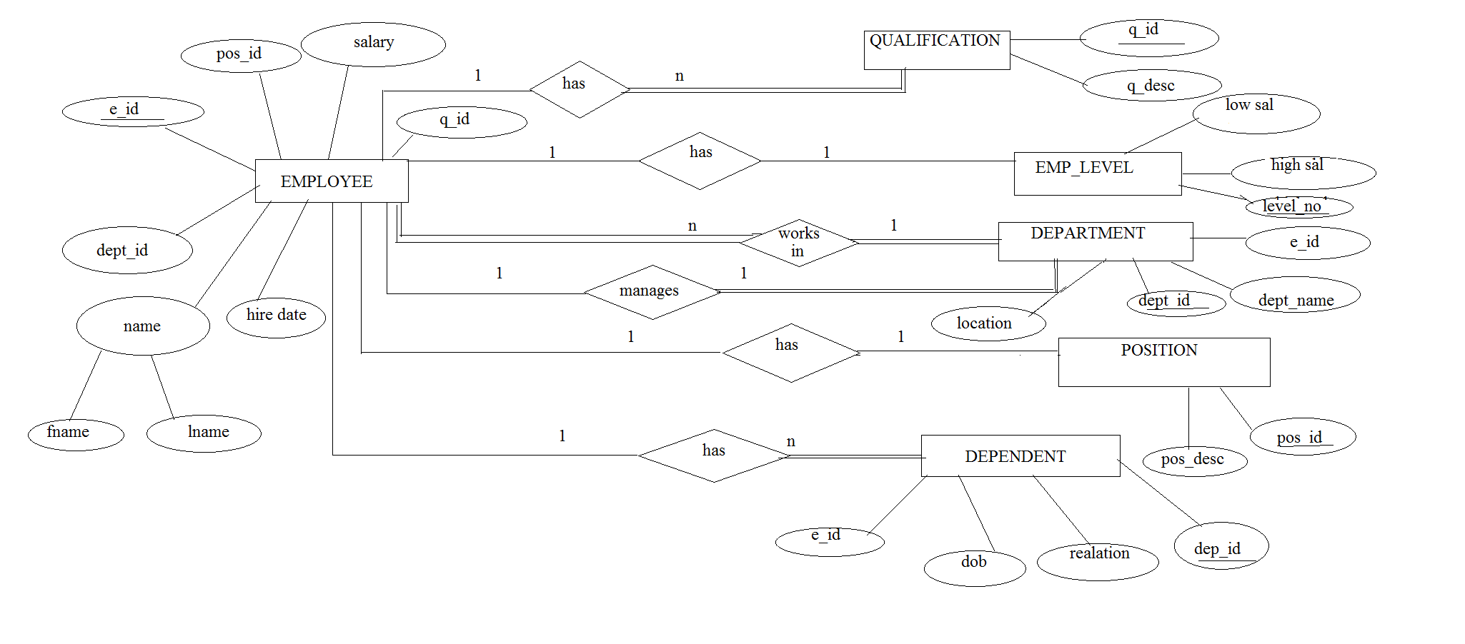

Fig 4.2 ER diagram

**4.3 Schema Diagram**

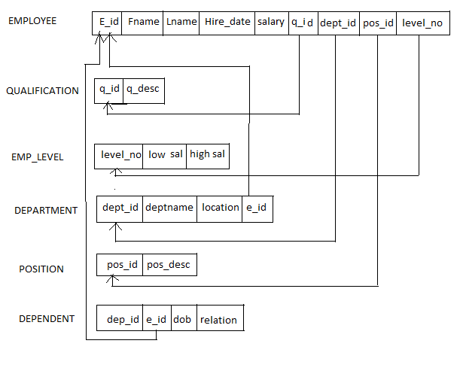

Fig 4.3 Schema Diagram

**4.4 Flow charts or DFDs**

* Login

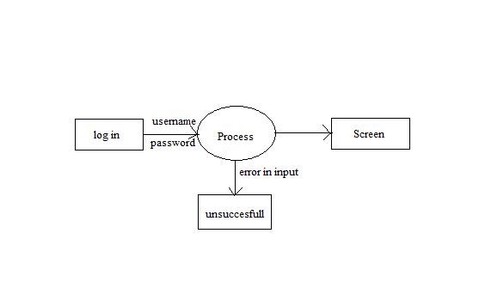

Fig 4.1 login

* Main menu

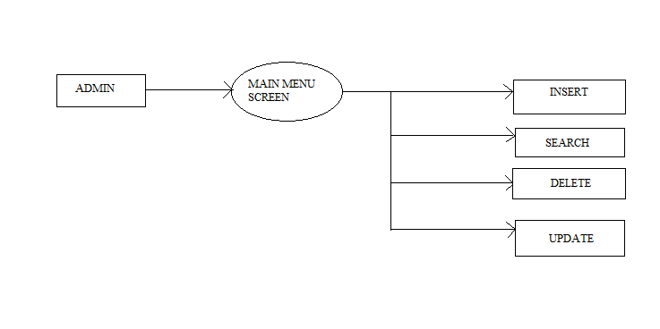

Fig 4.2 main menu

* Insert

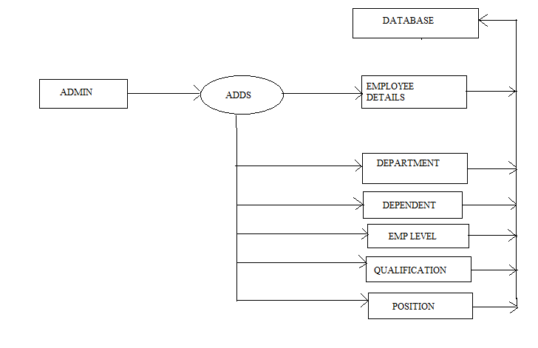Fig 4.3 insert

* Delete

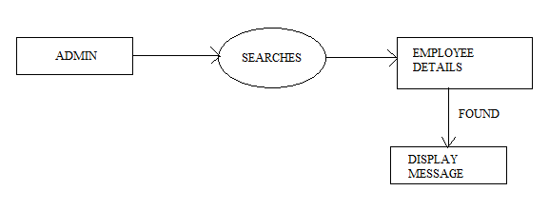

Fig 4.4 search

* Delete

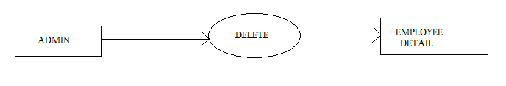

Fig 4.5 delete

* Update

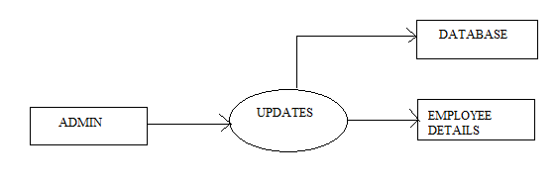

Fig 4.6 update

**CHAPTER 5**

**IMPLEMENTATION**

**CHAPTER 5**

**IMPLEMENTATION**

**5.1 Tools and language used.**

The tools used in this project are as follows:

* **Hardware Tools**

1.Processor: x86 compatible processor with 1.7 Ghz Clock Speed

2. RAM:-512 MB or greater

3. Hard Disk:-20GB or greater

4. Monitor: VGA/SVGA

5. Keyboard:-104 keys standard

6. Mouse:-2/3 button Optical/Mechanical

* **Software Tools**

1. Operating System: Windows 10.

2. Browser (Chrome/Firefox)

3. Front end: Java Net beans

4. Rear end: Oracle or MySQL

The Scripting language used in this project is JAVA

**5.2 Modules.**

**5.2.1 Module 1 – login**

This module lets the administrator to log in so that he/she can have an access to the information regarding to the employee. The log in module enables the administrator to get an access to the information of the employee by typing his/her username followed by the correct password for the respective username. Also this module has the stored procedure which is called for different administrators using the callable statement.

package hr;

import java.swing.JOptionPane;

import java.sql.CallableStatement;

import java.sql.DriverManager;

import java.util.logging.Logger;

private void jButtonActionPerformed(java.awt.event.ActionEvent evt)

{

try{

Connection con=DriverManager.getConnection(‘jdbc:mysql://localhost/employee”,”root”,” ”);

String query =”{CALL ADMINLOGIN(? ? ?)”:

CallableStatement cs=con.preparedCall(query);

cs.setString(1,Username);

cs.setString(1,password);

cs.registerOutParameter(3,Types.INTEGER);

cs.execute( );

int count =cs.getInt(3);

if(count==1)

{

JOptionPane.showMessageDialog(null,”login successful!!!”+”\n”+”welcome admin”);

menuif nm=new menuif( );

this.getParent().add(nm);

nm.setVisible(true);

}

else{

JoptionPane.showmessageDialog(null,”unsuccessful”);

}}

**5.2.2 Module 2 – main menu**

The main menu lets the administrator to select the various operations such as insert, delete, search and update depending upon the operation to be performed. The main menu has the options insert, delete, search and update which lets the administrator to insert the employee, qualification, department, dependent etc , delete the employee, update the employee’s information and search any employee that exists in the organization.

package hr;

import java.awt.Color;

import java.sql.*;

import javax.swing.*;

public class menuif extends javax.swing.JInternalFrame {

public menuif() {

initComponents();

getContentPane().setBackground(Color.MAGENTA);

}

private void jMenuItem1ActionPerformed(java.awt.event.ActionEvent evt) {

addemployee a=new addemployee();

dp2.add(a);

a.setVisible(true);

}

private void jMenuItem2ActionPerformed(java.awt.event.ActionEvent evt) {

deptdb d=new deptdb();

dp2.add(d);

d.setVisible(true);

}

deleteemp de=new deleteemp();

dp2.add(de);

de.setVisible(true);

}

private void jMenuItem13ActionPerformed(java.awt.event.ActionEvent evt) {

editemp ee=new editemp();

dp2.add(ee);

ee.setVisible(true);

}

private void jMenuItem7ActionPerformed(java.awt.event.ActionEvent evt) {

searchemp se=new searchemp();

dp2.add(se);

se.setVisible(true); }

**5.2.3 Module 3 – insert.**

This module enables the administrator to insert the details of new employees, qualification department, dependent, employee level and position.

* Insertion of new employee.

package hr;

import java.awt.Color;

import java.sql.*;

import javax.swing.*;

public class addemployee extends javax.swing.JInternalFrame {

public addemployee() {

initComponents();

getContentPane().setBackground(Color.ORANGE);

}

private void jbutton1ActionPerformed(java.awt.event.ActionEvent evt) {

try{

stmt.execute("INSERT INTO addemployee (NAME,BIRTHDAY,BIRTHMONTH,BIRTHYEAR,ID,ADDRESS,SEX,SALARY,DEPARTMENTID,POSITIONID,QUALIFICATIONID,MOBILE,HIREDAY,HIREMONTH,HIREYEAR)VALUES('"+NameText.getText()+"','"+ BirthDay.getSelectedItem()+"','"

+ BirthMonth.getSelectedItem()+"','"+ BirthYear.getSelectedItem()+"','"+ id.getText()+"','"+ address.getText()+"','"+ sex.getSelectedItem()+"','"

+ salary.getText()+"','"+ department.getSelectedItem()+"','"+ pos.getSelectedItem()+"','"+ qualification.getSelectedItem()+"','"+ mobile.getText()+"','"+ HireDay.getSelectedItem()+"','"+ HireMonth.getSelectedItem()+"','"+ HireYear.getSelectedItem()+"')");

catch(SQLException ex)

{

JOptionPane.showMessageDialog(null,ex.toString());

}

}

* Insertion of department.

private void jButton1ActionPerformed(java.awt.event.ActionEvent evt) {

try{

stmt.execute("INSERT INTO deptdb(DEPARTMENTID,DEPARTMENTNAME,LOCATION,MANAGEMENTID)VALUES('"+DepartmentId.getText()+"','"+ DeptName.getText().toString()+"','"

+ location.getText().toString()+"','"+ managementid.getText()+"')");

JOptionPane.showMessageDialog(null,"Employee addedto database"); }

* Insertion of dependent.

private void jButton1ActionPerformed(java.awt.event.ActionEvent evt) {

try{

stmt.execute("INSERT INTO depdb(EMPLOYEEID,DEPENDENTID,DEPENDENTDOB,RELATION)VALUES('"+empid.getText()+"','"+ denid.getText()+"','"

+ dendob.getText()+"','"+rel.getText()+"')");

JOptionPane.showMessageDialog(null,"Employee addedto database");

* Insertion of employee level

private void jButton1ActionPerformed(java.awt.event.ActionEvent evt) {

try{

stmt.execute("INSERT INTO empldb (LEVELNO,LOWSALARY,HIGHSALARY)VALUES('"+levelno.getText()+"','"+ lowsal.getText()+"','"

+ highsal.getText()+"')");

JOptionPane.showMessageDialog(null,"Employee addedto database");

}

* Insertion of qualification

private void jButton1ActionPerformed(java.awt.event.ActionEvent evt) {

try{

stmt.execute("INSERT INTO qualdb(QUALIFICATIONID,QUALIFICATIONDESCRIPTION)VALUES('"+qualid.getText()+"','"+ Desc.getText()+"')");

JOptionPane.showMessageDialog(null,"Employee addedto database");

* Insertion of position

private void addbtnActionPerformed(java.awt.event.ActionEvent evt) {

try{

stmt.execute("INSERT INTO posdb (POSITIONID,POSITIONDESCRIPTION)VALUES('"+posid.getText()+"','"+ posd.getText()+"')");

JOptionPane.showMessageDialog(null,"Employee addedto database");

}

**5.2.4 Module 4 – Search**

The administrator or the HR can easily search any employee of the organization. This module allows the HR to search the information of any employee easily without any complications. If the employee’s information exists in the database then a message that the record is found will be displayed

private void jButton1ActionPerformed(java.awt.event.ActionEvent evt) {

int result= List1.getNextMatch(SearchText.getText(),0, Position.Bias.Forward);

List1.setSelectedIndex(result);

}

**5.2.4 Module 5 – delete**

This module allows the administrator to delete the records of an employee who has left the organization due to relevant reasons or has been removed by the organization .In this the HR can keep the track of all the employees that are currently present in the organization without having any problems . By just entering the employee id the entire information related to that employee will be deleted from the database.

private void jButton1ActionPerformed(java.awt.event.ActionEvent evt) {

try{

String Query="delete from addemployee where '"+eid.getText()+"'=id";

stmt.execute(Query);

JOptionPane.showMessageDialog(null,"Employee is deleted from database");

}

**5.2.5 Module 6 – Update.**

This module allows the Administrator to update the information of the existing employees .The administrator can simply edit the information regarding to that particular employee. After editing the information the changes made will be displayed at the left side of the frame .Thus eases the job of the administrator in updating.

private void jButton1ActionPerformed(java.awt.event.ActionEvent evt) {

try{

String Query="delete from addemployee where '"+eid.getText()+"'=id";

int result= List1.getNextMatch(UpdateText.getText(),0, Position.Bias.Forward);

List1.setSelectedIndex(result);

}

**CHAPTER 6**

**TESTIING**

## **CHAPTER 6**

**TESTING**

### **6.1 TEST CASE – 1: HOME PAGE**

|  |  |
| --- | --- |
| **Test Description** | What action take place when clicking on the login tab. |
| **Sample Input** | Click on login tab. |
| **Expected Output** | Redirect to login page. |
| **Actual Output** | Redirect to login page. |
| **Remark** | Pass |

### **6.2 TEST CASE – 2: ADMIN LOGIN**

|  |  |
| --- | --- |
| **Test Description** | What action take place when clicking on SUBMIT button with valid username (which is stored) and password. |
| **Sample Input** | Click on SUBMIT button with valid username and password. |
| **Expected Output** | Redirect to main menu. |
| **Actual Output** | Redirect to main menu. |
| **Remark** | Pass |

### **6.3 TEST CASE – 3: ADMIN LOGIN**

|  |  |
| --- | --- |
| **Test Description** | What action take place when clicking on SUBMIT button with username (which is not stored) and password. |
| **Sample Input** | Click on SUBMIT button with username and password. |
| **Expected Output** | Redirect to home page. |
| **Actual Output** | Error message displaying as unsuccessful |
| **Remark** | Pass |

**6.4 TEST CASE – 4: INSERT**

|  |  |
| --- | --- |
| **Test Description** | What action take place when clicking on insert in main menu page. |
| **Sample Input** | Click on insert. |
| **Expected Output** | Clicking on insert will display the list of insert options. |
| **Actual Output** | Clicking on insert will display the list of insert options. |
| **Remark** | Pass |

**6.5 TEST CASE – 5: INSERT**

|  |  |
| --- | --- |
| **Test Description** | What action takes place when on any of the option from the insert list is clicked |
| **Sample Input** | Click on any of the option. |
| **Expected Output** | Clicking on any of the option will redirect to that respective option page. |
| **Actual Output** | Clicking on any of the option will redirect to that respective option page. |
| **Remark** | Pass. |

**6.6 TEST CASE – 6: DELETE**

|  |  |
| --- | --- |
| **Test Description** | What action take place when clicking on the employee tab under delete. |
| **Sample Input** | Click on employee tab. |
| **Expected Output** | Clicking on employee will redirect to the delete page. |
| **Actual Output** | Clicking on employee will redirect to the delete page. |
| **Remark** | Pass. |

**6.7 TEST CASE – 7: SEARCH**

|  |  |
| --- | --- |
| **Test Description** | What action take place when we click on the search button. |
| **Sample Input** | Click on search button. |
| **Expected Output** | Clicking on search button will redirect to search page where we can search for employee. |
| **Actual Output** | Clicking on search button will redirect to search page where we can search for employee. |
| **Remark** | Pass. |

**6.8 TEST CASE – 8: EDIT**

|  |  |
| --- | --- |
| **Test Description** | What action take place when we click on the edit button. |
| **Sample Input** | Click on edit button |
| **Expected Output** | Clicking on the edit button will redirect to edit page where we can edit the information of the employee |
| **Actual Output** | Clicking on the edit button will redirect to edit page where we can edit the information of the employee. |
| **Remark** | Pass. |

**CHAPTER 7**

**SNAPSHOTS**

**CHAPTER 7**

**SNAPSHOTS**

**7.1 Home Page.**

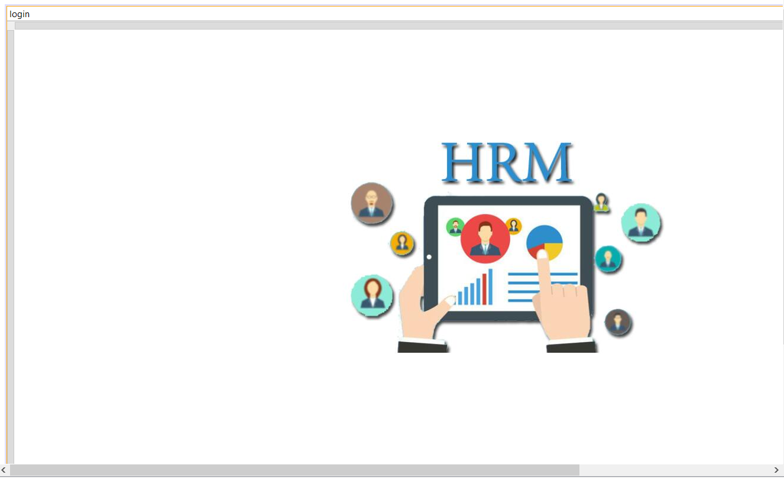

Fig 7.1 main frame

**7.1 Login.**

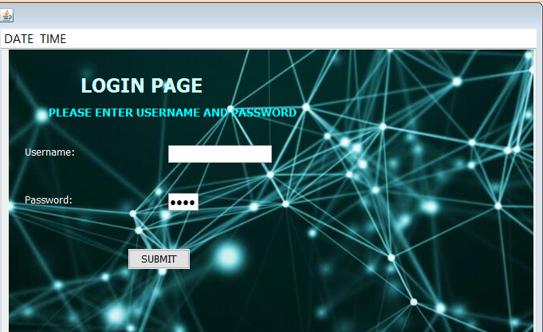

Fig 7.2 login page

**7.1 Mainmenu**

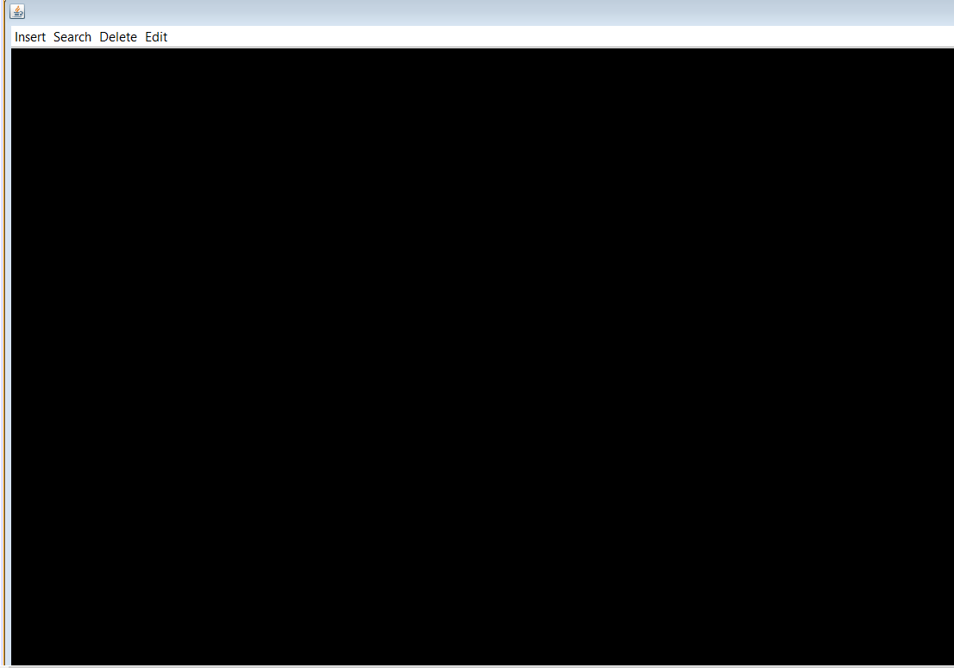

Fig 7.3 main menu

**7.1 Insert**

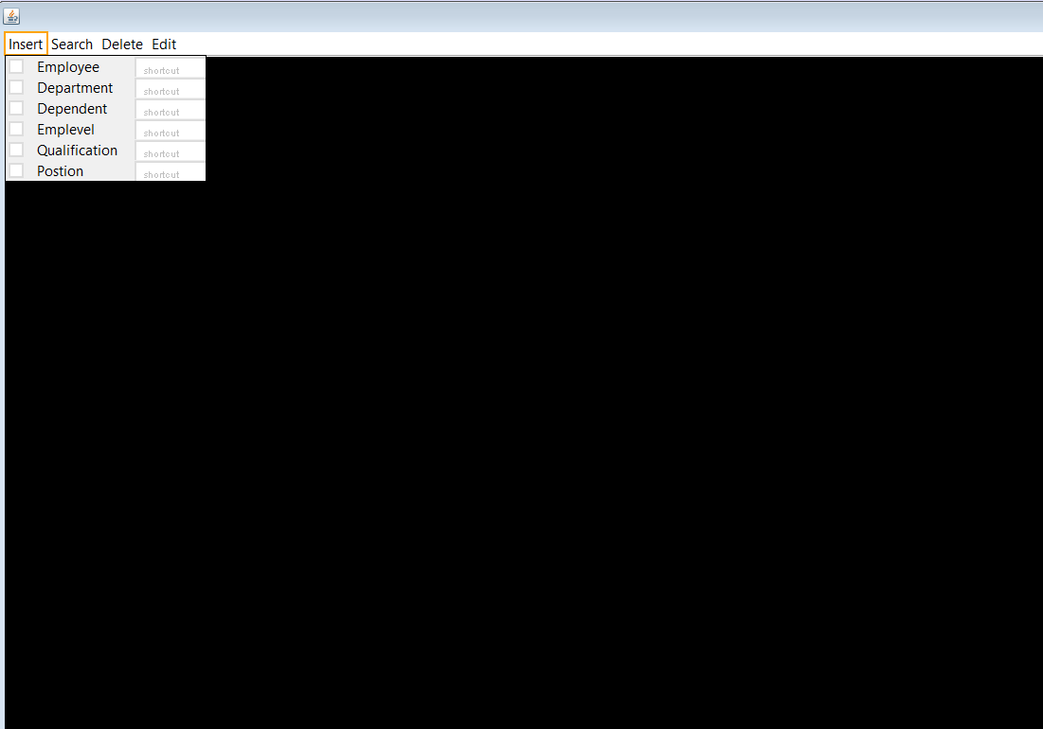

Fig 7.4 selecting insert

**7.1.Insertion of employee details**

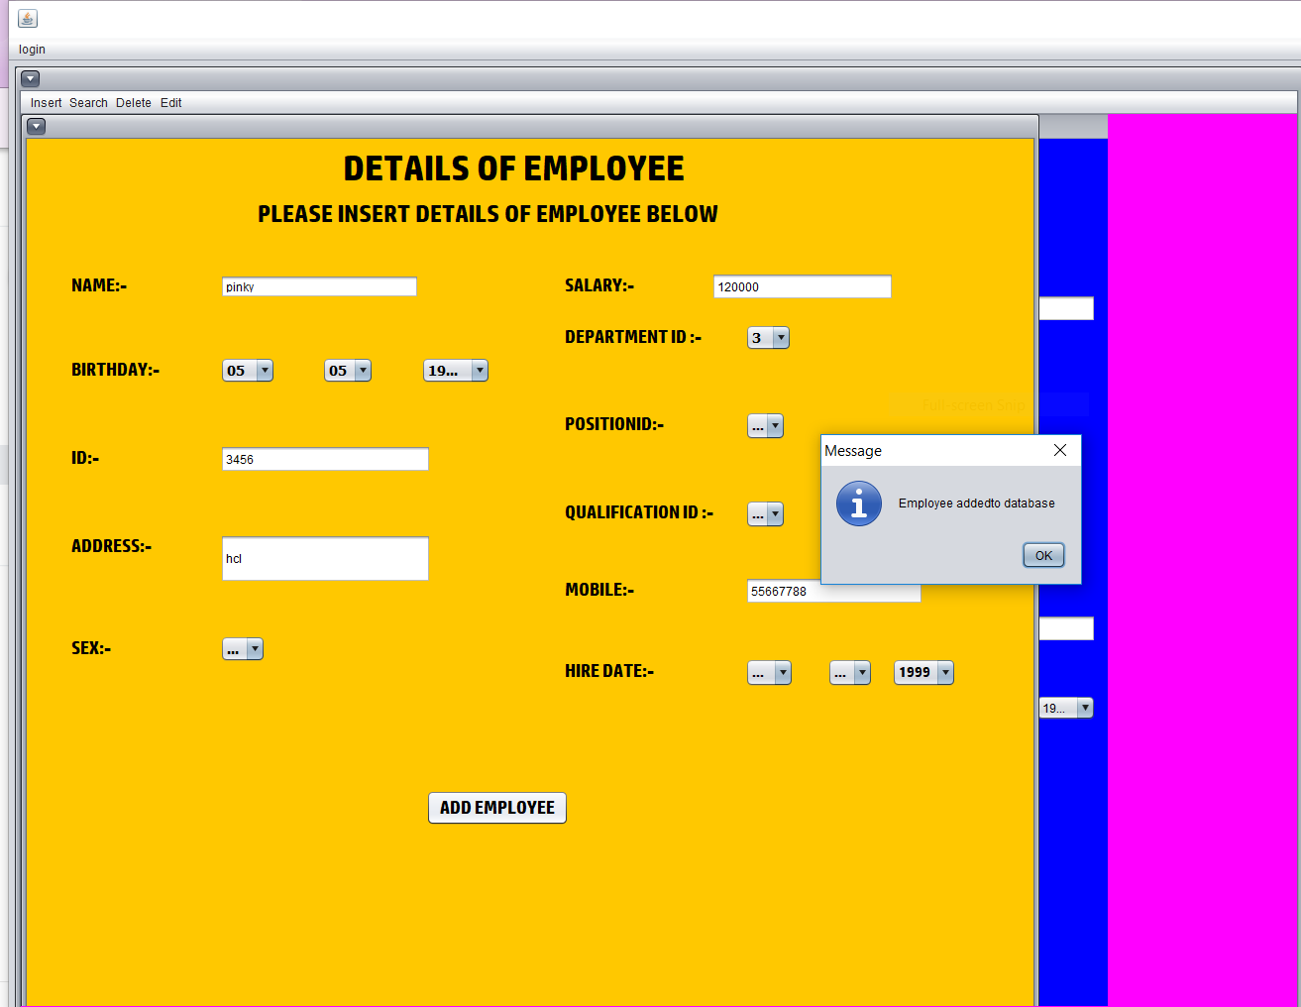

Fig 7.6 inserting employee details

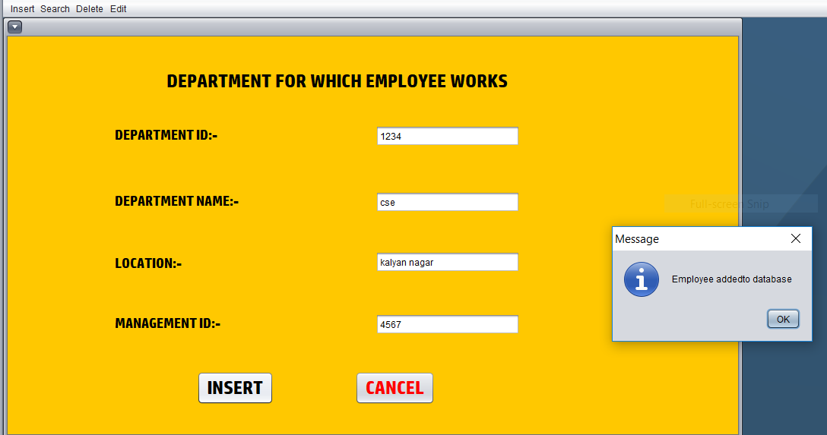**7.1.Insertion of department**

Fig 7.7 inserting department

**7.2 Delete**

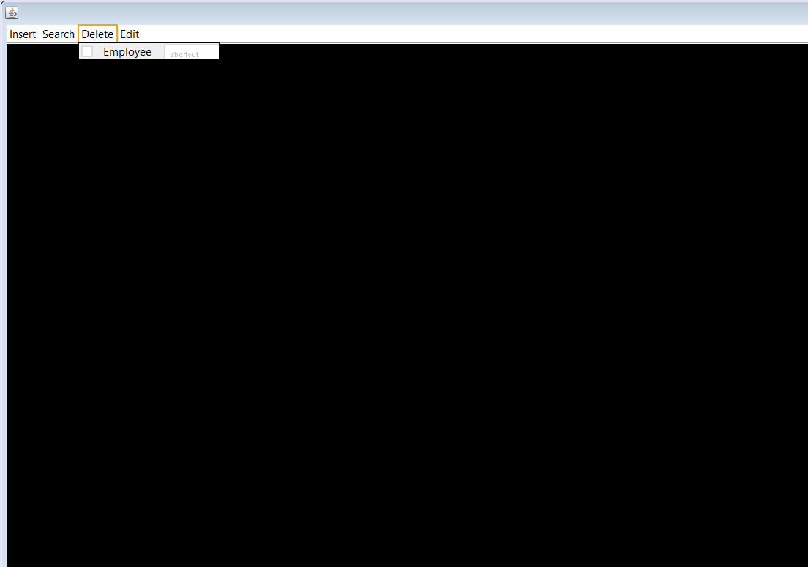

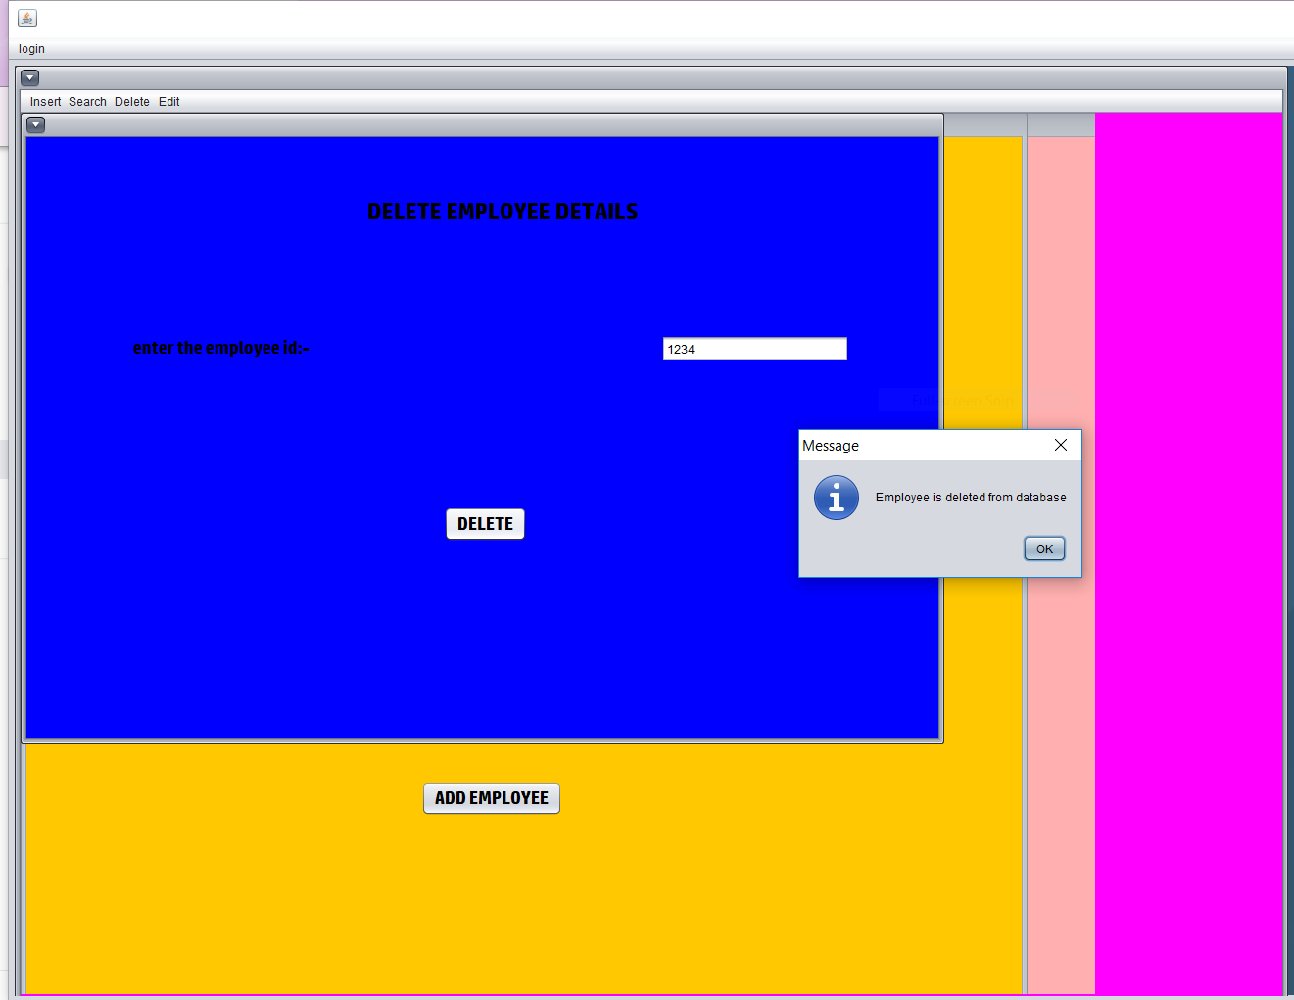Fig 7.8 selecting delete

Fig 7.9 deleting of employee details

**7.4 Update**

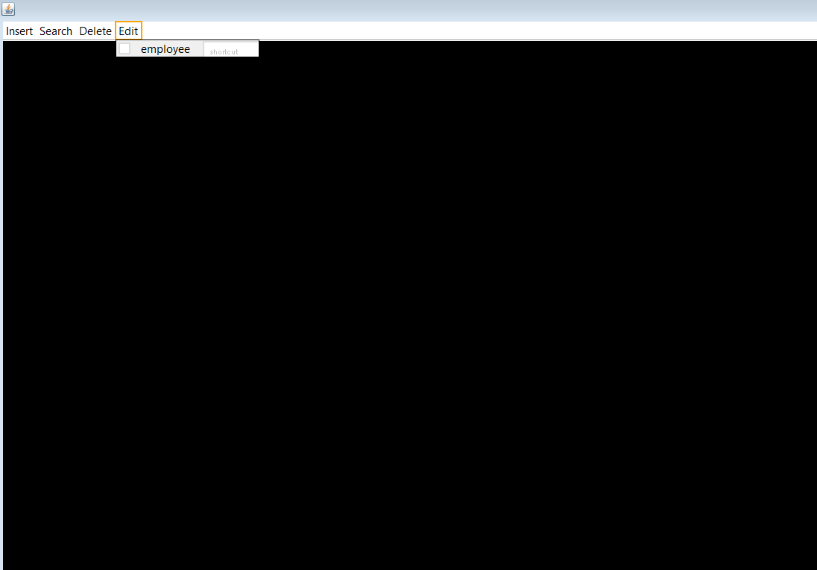

Fig 7.10 selecting update

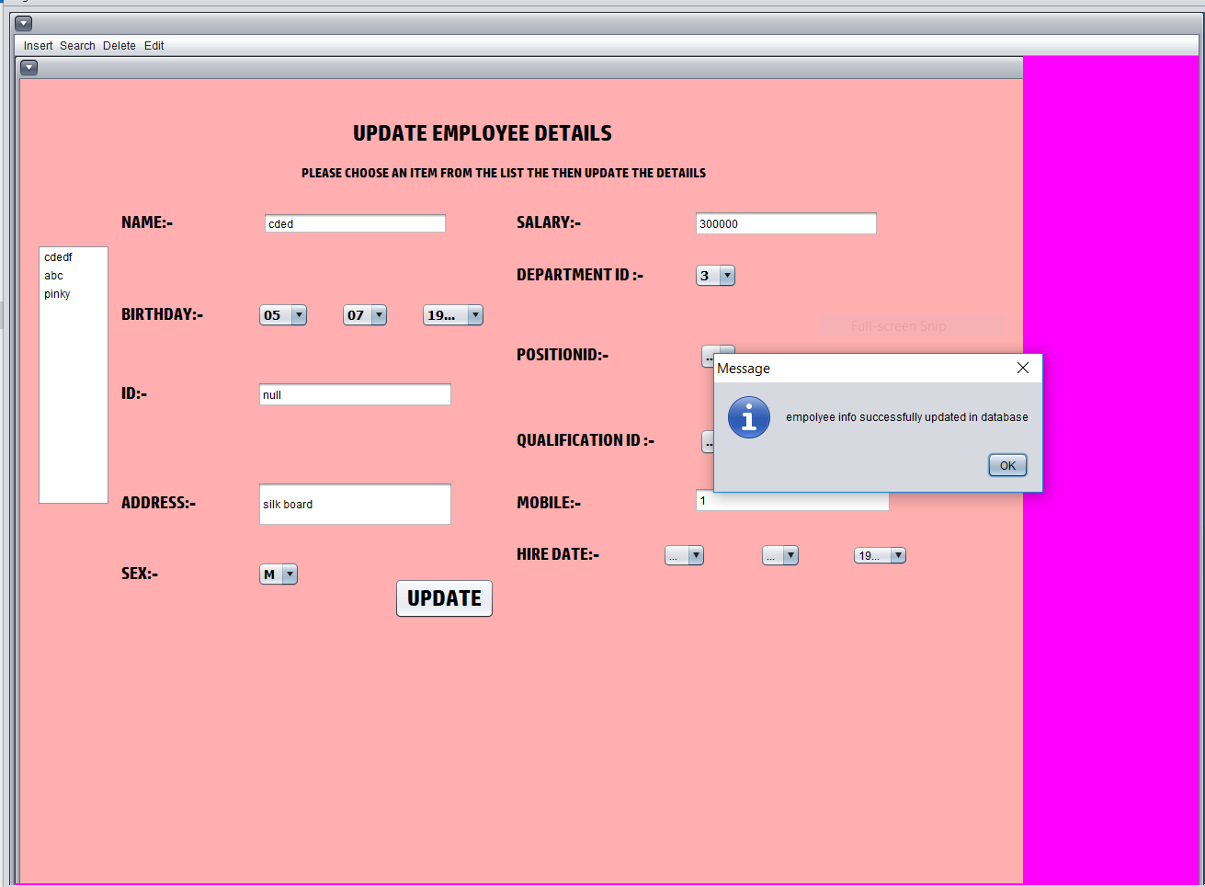

Fig 7.11 updating the employee information

**7.5 Search**

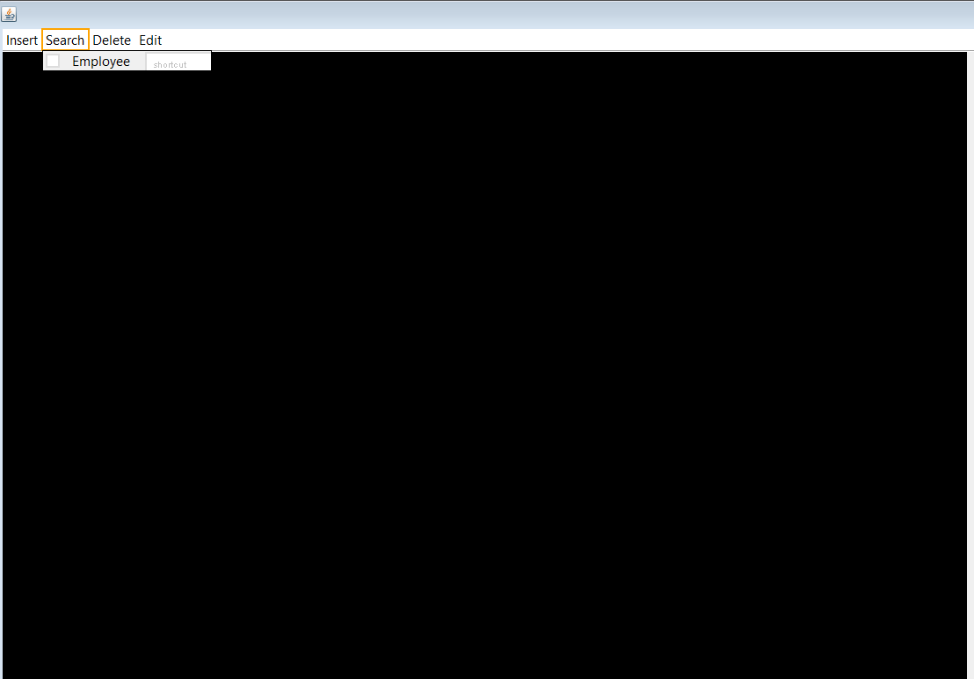

Fig 7.12 selecting search

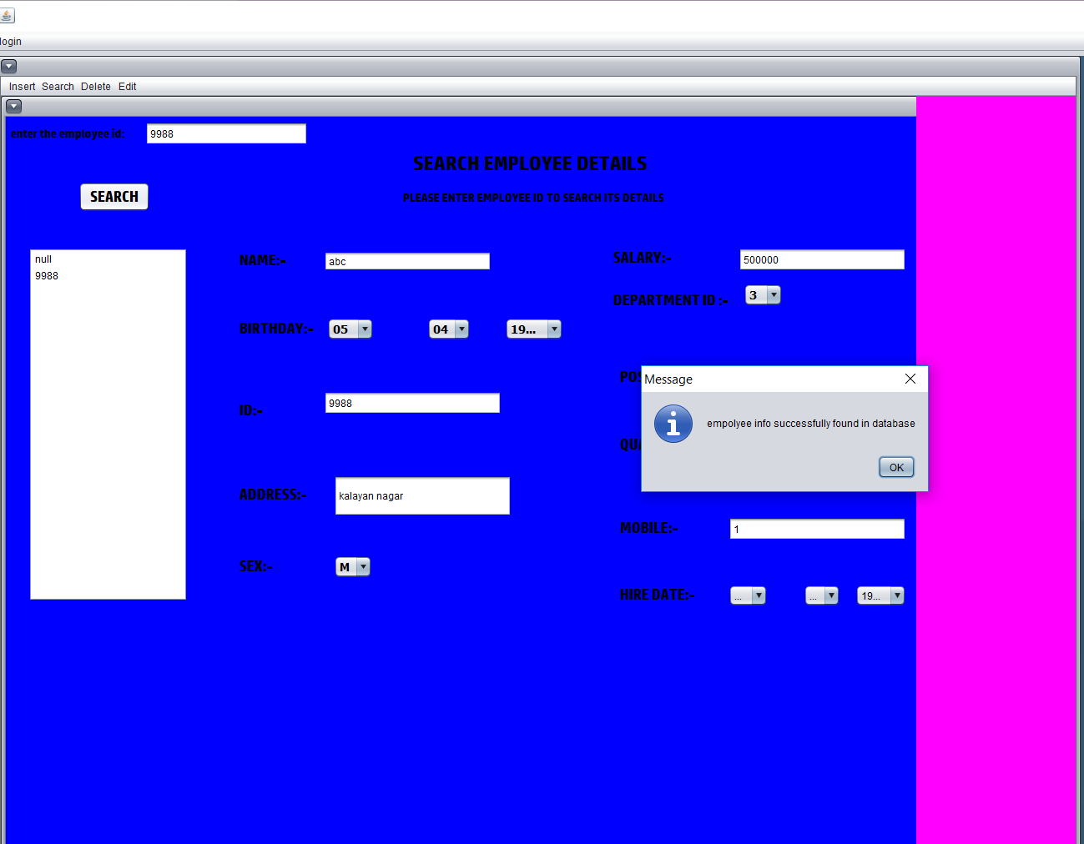

Fig 7.13 reteiving details after search

**CHAPTER 8**

**CONCLUSION AND FUTURE WORK**

**CHAPTER 8**

**CONCLUSION AND FUTURE WORK**

**Conclusion.**

The project helps the HR of an organization to keep a track about the employee’s information Most of the requirements have been fulfilled up to the mark This project ensures that the system is accurate enough to store the data of the organization. The system also helps in the well maintenance of the organization which in turn benefits the organization’s reputation. Also the other requirements can be fulfilled with a short extension.

**Future work.**

The project made here is just to ensure that this product could be valid in today’s real challenging world. Here all the facilities are made and tested. Currently the system works for limited number of administrators to work .In the near future it will be extended for many types of insurance policies so that efficiency can be improved.

**REFERENCES**

1 .”The Complete Reference Java” Tata McGraw-Hill publishing Company Limited. By Herbert Schildt .

2.”Software Engineering, A practitioner’s approach” Tata McGraw-Hill Publishing Company

Limited .By Roger S. Pressman

3.”PL/SQL” by Ivan Bayross

|  |
| --- |
|  |
|  |

|  |
| --- |
| **VISVESVARAYA TECHNOLOGICAL UNIVERSITY**  **Jnana Sangama, Belagavi- 590 018** |
| **Description: VTU-Logo-New-Trans.png** |
|  |
| **A**  **Mini Project Report**  **On**  **“Human Resource Database Management System”**  Submitted in partial fulfillment for the award of the Bachelor of Engineering degree  In  Computer Science and Engineering  V Semester  1**5CSL58 – DBMS Laboratory with Mini Project**  For the academic year 2018 – 2019  By |
| **Aastha Gupta 1HK16CS003**  **Fathima Zohra 1hk16CS047**  **Under the guidance of**  **Mrs.Amreen Manjula &**  **Mrs. Manjula H.T**  **Assistant Professor, Department of Computer Science and Engineering**  **December 2018**  **HKBKCE Logo with out KSMF**  **Department of Computer Science & Engineering**  **HKBK COLLEGE *of* ENGINEERING**  **(Approved by AICTE & Affiliated to VTU)**  **22/1, Nagawara, Arabic College Post, Bangalore-45, Karnataka**  **Email: info@hkbk.edu.in URL: www.hkbk.edu.in**  **2018 - 2019** |
|  |
|  |
|  |

|  |  |  |
| --- | --- | --- |
| _____________________ | _____________________ | _____________________ |
| Mr./Ms. Name | Prof. Loganathan R. | Dr. Chaitanya Kumar M. V. |
| Coordinator | Head of the Department | Principal |

|  |  |  |
| --- | --- | --- |
| _____________________ |  | _____________________ |
| Mrs. Manjula H. T |  | Dr. Loganathan R |
| Guide |  | Professor &HOD |

|  |  |
| --- | --- |
| External Viva | |
| Name of the Examiners | Signature with Date |
| 1. _______________________________ |  |
| 1. _______________________________ | ______________________________ |

|  |  |
| --- | --- |
|  | **HKBK COLLEGE *of* ENGINEERING**  Nagawara, Bangalore -5600 47  Approved by AICTE & Affiliated to VTU |

**Department of Computer Science and Engineering**

**Certificate**

Certified that the Project Work entitled **“Human Resource Database Management System”,** carried out by **Aastha Gupta (1HK16CS003) and Fathima Zohra (1HK16CS047)** bonafide students of **HKBK COLLEGE *of* ENGINEERING**, in partial fulfillment for the award of **Bachelor of Engineering** in **Computer Science and Engineering** of the **Visvesvaraya Technological University**, Belgavi, during the year 2018–19. It is certified that all corrections/suggestions indicated for Internal Assessment have been incorporated in the report deposited in the departmental library. The project report has been approved as it satisfies the academic requirements in respect of **15CSL58–DBMS Laboratory with Mini Project** prescribed for the said Degree.

**ABSTRACT**

The System Human Resource Database Management System creates software that stores and manages all the data needed to describe the personal and their framework within an organization .It includes definition of various levels of hierarchy in an organization, the description of every department functioning in the organization and the overall employ database which integrates elements in all the afore mentioned. It has database administration that has access to the entire database, in regards with viewing and update of information. The exclusive right is implemented using authorized access. Also viewing all data and editing of personal data can be done by HR. The data can be accessed, manipulated and retrieved very easily. The interface has been made very friendly. The data is well protected for use and the data processing i,e result of query functions has been made very quick and efficient.

# **TABLE OF CONTENTS**

Acknowledgment i

Abstract ii

## **CHAPTER 1. INTRODUCTION**

1.1 Introduction 1

1.2 Problem Statement 1

1.3 Proposed solution 1

1.4 Objectives 2

1.5 Outcomes of the Project 2

## **CHAPTER 2. REQUIREMENT ANALYSIS**

2.1 Initial Investigation 3

2.2 Information Gathering 3

2.3 Feasibility Study 3

2.4 Existing System 4

2.5 Proposed System 4

2.6 Advantages of proposed system 5

## **CHAPTER 3. SYSTEM REQUIREMENT SPECIFICATION**

3.1 Functional Requirements 6

3.2 Non-Functional Requirements 6

## **CHAPTER 4. SYSTEM DESIGN**

4.1 System Architecture 7

4.2 ER diagram 8

4.3 Schema diagram 9

4.4 Flow Chart 10

**CHAPTER 5. IMPLEMENTATION**

5.1 Tools and Languages Used 13

5.2 Module

5.2.1 Module 1 - login 13

5.2.2 Module 2 – main menu 15

5.2.3 Module 3 - insert 16

5.2.4 Module 4 – search

5.2.5 Module 5 – delete 19

5.2.5 Module 6 - update 20

**CHAPTER 6. TESTING**

6.1 Test case 1: Home Page 21

6.2 Test case 2: Admin login 21

6.4 Test case 4: Admin login 21

6.5 Test case 5: Insert 22

6.6 Test case 6: Insert 22

6.7 Test case 7: Delete 22

6.8 Test case 8: Search 23

6.9 Test case 9: Edit 23

**CHAPTER 7. SNAPSHOTS**

7.1 Home Page 24

7.2 login 24

7.3 Main menu 25

7.4 Insert 25

7.5 Delete 27

7.6 Update 28

7.7 Search 29

**CHAPTER 8. CONCLUSION AND FUTURE WORK**

Conclusion and Future Work 30

**References**

**CHAPTER 1**

**INTRODUCTION**

**CHAPTER 1**

**INTRODUCTION**

**1.1 Introduction**

The Project has been developed keeping in view to develop a system that deals with the day to day requirement of an organization and also to enable the organization to come out with an easy to handle system of the Human Resource Management.

The Human Resource Database Management software is very friendly and appealing. The main objective of the system is to maintain and retrieve information about the entire personnel framework of the organizational system. This system is fairly simple in design and implementation. The proposed system is to design a hierarchical framework in terms of positions held. Thus depicting the organizational hierarchy. Update of the structure of the same as well as addition of new elements. We can search for all employees, departments, dependent information etc. is possible which can be department wise, level-wise and other parameter based search enabled. There is computerized payroll generation, manipulation and management. It is a easy management of databases of various sections covering key aspects.

**1.2 Problem Statement**

* Slow process of the organization’s human resource. In the past recording keeping was done on paper and with spreadsheets.
* No proper security of the employee’s information as well as the organization’s information.
* Difficulty in monitoring their daily records.
* Slow retrieval of data.
* Poor data storage.
* Unsecured data.

**1.3 Proposed Solution**

The proposed system provides detail general information about the employee along with Educational, Certification, Skill and project details.

It enhances the HR management in adding, viewing and updating employees’ details and generates various reports regarding employees’ skill and experience. Improved manual system is another solution for the improvement of the system. Also it promises very less or no paper work and also provides help administrate and electronically. Information can be retrieved very easily.

**1.4 Objectives.**

Human Resource Information System is a systematic way of storing data and information for each individual for each individual employee to aid planning, decision making and submitting of returns and reports to the external agencies. It is an online solution for the data entry and tracking of a company’s human resources department information, payroll, management and accounting An effective HRS provides information on just about anything the company needs to track and analyze about employees, former employees and applicants.

**Thus in a nutshell, an HRS serves the following functions:**

* Storing information and data of each individual employee
* Providing a basis for planning, decision making, controlling and other human resource functions.
* Supplying data and submitting it the organization
* Retrieving data about individual employee.
* Modifying the information related to a particular employee .

**1.5 Outcomes of the project.**

* Contribute to the development, implementation, and evaluation of employee.
* Develop, implement, and evaluate organizational development strategies aimed at promoting organizational effectiveness.
* Conduct research, produce reports, and recommend changes in human resources practices.
* The organization can keep the track of the number of employees

Easy and effective maintenance job can be done without having any redundancy

**CHAPTER 2**

**REQUIREMENT ANALYSIS**

**CHAPTER 2**

**REQUIREMENT ANALYSIS**

**2.1 Initial Investigation.**

The need of a software that can maintain the details of the employees working in an organization and also to protect their information lead to the development of this system. Initially, there was only manual system for storing their information. As this is a tedious process an approach towards the computerized data storage lead to the development of this system.

**2.2 Information Gathering.**

There are a series of activities regarding to this section such as analyzing, tracking and utilizing data on project. With the help of google as search browser information was gathered. Need for training that is the administrator has to be well trained for the smooth running of the system

**2.3 Feasibility study.**

Once the problem is clearly understood, the next step is to conduct feasibility study, which is high high-level capsule version of the entered systems and design process. The objective is to determine whether or not the proposed system is feasible.

* **Technical Feasibility**

In technical Feasibility study, one has to test whether the proposed system can be developed using existing technology or not. It is planned to implement

the proposed system using java technology. It is evident that the necessary hardware and software are available for development and implementation of the proposed system. Hence, the solution is technically feasible.

* **Economic Feasibility**

As part of this, the costs and benefits associated with the proposed system compared and the project is economically feasible inly if tangible or intangible benefits outweigh costs. The system development costs will be significant. So the proposed system is economically feasible.

* **Operational Feasibility**

It is a standard that ensures interoperability without stifling competition and innovation among users, to the benefit of the public both in terms of cost and service quality. The proposed system is acceptable to users. So the proposed system is operationally feasible.

**2.4 Existing system**

A few drawbacks of the existing system are:

* Need of extra manual effort
* It used to take much time to find any employee
* Not very much accurate
* Danger of losing the files in some cases

**2.5 Proposed System**

The proposed system provides detail general information about the employee along with Education, Certification skill and project details.it enhances the HR management in adding, viewing and updating employees’ details and generates various reports regarding employee’s skill and experience. Suggestions and Grievances posted by the employees are update for taking care of the necessary steps in forwarding company’s obligations.

**2.6 Advantages of the Proposed System**

* Very simple and easy to implement
* Security of data
* Ensure data accuracy
* Administrator discretion and control over the entire system
* Reduces the damages of machine
* Minimizes manual data entry
* Greater efficiency
* User friendly and interactive
* Less time comsuming

**CHAPTER 3**

**SYSTEM REQUIREMENTS**

**CHAPTER 3**

**SYSTEM REQUIREMENT SPECIFICATION**

**3.1 Functional Requirements**

The Functional Requirements Specification documents the operations and activities that a system is able to perform .It is designed to be read by a general audience. Readers should understand the system, but no particular technical knowledge should be required. The Human Resource Management System provides following functionality for effective usage and maintenance of human resource information.

**Administrator:**

1. Add:-Adds the details of the Employee to the database.

2. Delete:-Delete the details of the any Employee to the database.

3. Update:-we can update the details of employee. Suppose, in case any employee is being hired for some top position for the company then details of that particular employee needs to be updated or if some employee address is changed recently, it needs to be updated.

4. Search:-The admin can use any SQL commands to retrieve any information concerning the database.

**3.2 Non Functional Requirements**

**3.2.1 Safety Requirements**

There are several user levels in Human Resource Management System. Access to the various subsystems will be protected by a user login, which requires a username and password. This gives different views and accessible functions of user levels through the system. Maintaining backups ensure the system database security.

**3.2.2 Security Requirements**

Admin will be able to login to the Human Resource Management Database System. Admin will have access to the management subsystem as well as the user account but he has the maximum privileges. Anyone who is not registered will not be able to access the database.

**CHAPTER 4**

**SYSTEM DESIGN**

**CHAPTER 4**

**SYSTEM DESIGN**

**4.1 System Architecture**

**Database administrator HR database management system**

**Fig 4.1 System Architecture**

**4.1.1 Administration module:**

This module is protected by the username and password .Ordinary users will not be permitted to enter this area of the software. The administrator can modify the data that has been already entered and also can insert/add new data into the database and can also update and delete the database. The administrator plays an important role in this database system. The administrator has a username and the required password to have access to the main menu of the database.

**4.1.2 Database:**

Data are known facts that can be recorded and that have implicit meaning. Database management system is a collection of programs that enables users to create and maintain the database. It is a general-purpose software system that facilitates the processes of defining, constructing, manipulating, and sharing database among various users and applications.

**4.2: ER-DIAGRAM**



Fig 4.2 ER diagram

**4.3 Schema Diagram**



Fig 4.3 Schema Diagram

**4.4 Flow charts or DFDs**

* Login



Fig 4.1 login

* Main menu



Fig 4.2 main menu

* Insert

Fig 4.3 insert

* Delete



Fig 4.4 search

* Delete



Fig 4.5 delete

* Update



Fig 4.6 update

**CHAPTER 5**

**IMPLEMENTATION**

**CHAPTER 5**

**IMPLEMENTATION**

**5.1 Tools and language used.**

The tools used in this project are as follows:

* **Hardware Tools**

1.Processor: x86 compatible processor with 1.7 Ghz Clock Speed

2. RAM:-512 MB or greater

3. Hard Disk:-20GB or greater

4. Monitor: VGA/SVGA

5. Keyboard:-104 keys standard

6. Mouse:-2/3 button Optical/Mechanical

* **Software Tools**

1. Operating System: Windows 10.

2. Browser (Chrome/Firefox)

3. Front end: Java Net beans

4. Rear end: Oracle or MySQL

The Scripting language used in this project is JAVA

**5.2 Modules.**

**5.2.1 Module 1 – login**

This module lets the administrator to log in so that he/she can have an access to the information regarding to the employee. The log in module enables the administrator to get an access to the information of the employee by typing his/her username followed by the correct password for the respective username. Also this module has the stored procedure which is called for different administrators using the callable statement.

package hr;

import java.swing.JOptionPane;

import java.sql.CallableStatement;

import java.sql.DriverManager;

import java.util.logging.Logger;

private void jButtonActionPerformed(java.awt.event.ActionEvent evt)

{

try{

Connection con=DriverManager.getConnection(‘jdbc:mysql://localhost/employee”,”root”,” ”);

String query =”{CALL ADMINLOGIN(? ? ?)”:

CallableStatement cs=con.preparedCall(query);

cs.setString(1,Username);

cs.setString(1,password);

cs.registerOutParameter(3,Types.INTEGER);

cs.execute( );

int count =cs.getInt(3);

if(count==1)

{

JOptionPane.showMessageDialog(null,”login successful!!!”+”\n”+”welcome admin”);

menuif nm=new menuif( );

this.getParent().add(nm);

nm.setVisible(true);

}

else{

JoptionPane.showmessageDialog(null,”unsuccessful”);

}}

**5.2.2 Module 2 – main menu**

The main menu lets the administrator to select the various operations such as insert, delete, search and update depending upon the operation to be performed. The main menu has the options insert, delete, search and update which lets the administrator to insert the employee, qualification, department, dependent etc , delete the employee, update the employee’s information and search any employee that exists in the organization.

package hr;

import java.awt.Color;

import java.sql.*;

import javax.swing.*;

public class menuif extends javax.swing.JInternalFrame {

public menuif() {

initComponents();

getContentPane().setBackground(Color.MAGENTA);

}

private void jMenuItem1ActionPerformed(java.awt.event.ActionEvent evt) {

addemployee a=new addemployee();

dp2.add(a);

a.setVisible(true);

}

private void jMenuItem2ActionPerformed(java.awt.event.ActionEvent evt) {

deptdb d=new deptdb();

dp2.add(d);

d.setVisible(true);

}

deleteemp de=new deleteemp();

dp2.add(de);

de.setVisible(true);

}

private void jMenuItem13ActionPerformed(java.awt.event.ActionEvent evt) {

editemp ee=new editemp();

dp2.add(ee);

ee.setVisible(true);

}

private void jMenuItem7ActionPerformed(java.awt.event.ActionEvent evt) {

searchemp se=new searchemp();

dp2.add(se);

se.setVisible(true); }

**5.2.3 Module 3 – insert.**

This module enables the administrator to insert the details of new employees, qualification department, dependent, employee level and position.

* Insertion of new employee.

package hr;

import java.awt.Color;

import java.sql.*;

import javax.swing.*;

public class addemployee extends javax.swing.JInternalFrame {

public addemployee() {

initComponents();

getContentPane().setBackground(Color.ORANGE);

}

private void jbutton1ActionPerformed(java.awt.event.ActionEvent evt) {

try{

stmt.execute("INSERT INTO addemployee (NAME,BIRTHDAY,BIRTHMONTH,BIRTHYEAR,ID,ADDRESS,SEX,SALARY,DEPARTMENTID,POSITIONID,QUALIFICATIONID,MOBILE,HIREDAY,HIREMONTH,HIREYEAR)VALUES('"+NameText.getText()+"','"+ BirthDay.getSelectedItem()+"','"

+ BirthMonth.getSelectedItem()+"','"+ BirthYear.getSelectedItem()+"','"+ id.getText()+"','"+ address.getText()+"','"+ sex.getSelectedItem()+"','"

+ salary.getText()+"','"+ department.getSelectedItem()+"','"+ pos.getSelectedItem()+"','"+ qualification.getSelectedItem()+"','"+ mobile.getText()+"','"+ HireDay.getSelectedItem()+"','"+ HireMonth.getSelectedItem()+"','"+ HireYear.getSelectedItem()+"')");

catch(SQLException ex)

{

JOptionPane.showMessageDialog(null,ex.toString());

}

}

* Insertion of department.

private void jButton1ActionPerformed(java.awt.event.ActionEvent evt) {

try{

stmt.execute("INSERT INTO deptdb(DEPARTMENTID,DEPARTMENTNAME,LOCATION,MANAGEMENTID)VALUES('"+DepartmentId.getText()+"','"+ DeptName.getText().toString()+"','"

+ location.getText().toString()+"','"+ managementid.getText()+"')");

JOptionPane.showMessageDialog(null,"Employee addedto database"); }

* Insertion of dependent.

private void jButton1ActionPerformed(java.awt.event.ActionEvent evt) {

try{

stmt.execute("INSERT INTO depdb(EMPLOYEEID,DEPENDENTID,DEPENDENTDOB,RELATION)VALUES('"+empid.getText()+"','"+ denid.getText()+"','"

+ dendob.getText()+"','"+rel.getText()+"')");

JOptionPane.showMessageDialog(null,"Employee addedto database");

* Insertion of employee level

private void jButton1ActionPerformed(java.awt.event.ActionEvent evt) {

try{

stmt.execute("INSERT INTO empldb (LEVELNO,LOWSALARY,HIGHSALARY)VALUES('"+levelno.getText()+"','"+ lowsal.getText()+"','"

+ highsal.getText()+"')");

JOptionPane.showMessageDialog(null,"Employee addedto database");

}

* Insertion of qualification

private void jButton1ActionPerformed(java.awt.event.ActionEvent evt) {

try{

stmt.execute("INSERT INTO qualdb(QUALIFICATIONID,QUALIFICATIONDESCRIPTION)VALUES('"+qualid.getText()+"','"+ Desc.getText()+"')");

JOptionPane.showMessageDialog(null,"Employee addedto database");

* Insertion of position

private void addbtnActionPerformed(java.awt.event.ActionEvent evt) {

try{

stmt.execute("INSERT INTO posdb (POSITIONID,POSITIONDESCRIPTION)VALUES('"+posid.getText()+"','"+ posd.getText()+"')");

JOptionPane.showMessageDialog(null,"Employee addedto database");

}

**5.2.4 Module 4 – Search**

The administrator or the HR can easily search any employee of the organization. This module allows the HR to search the information of any employee easily without any complications. If the employee’s information exists in the database then a message that the record is found will be displayed

private void jButton1ActionPerformed(java.awt.event.ActionEvent evt) {

int result= List1.getNextMatch(SearchText.getText(),0, Position.Bias.Forward);

List1.setSelectedIndex(result);

}

**5.2.4 Module 5 – delete**

This module allows the administrator to delete the records of an employee who has left the organization due to relevant reasons or has been removed by the organization .In this the HR can keep the track of all the employees that are currently present in the organization without having any problems . By just entering the employee id the entire information related to that employee will be deleted from the database.

private void jButton1ActionPerformed(java.awt.event.ActionEvent evt) {

try{

String Query="delete from addemployee where '"+eid.getText()+"'=id";

stmt.execute(Query);

JOptionPane.showMessageDialog(null,"Employee is deleted from database");

}

**5.2.5 Module 6 – Update.**

This module allows the Administrator to update the information of the existing employees .The administrator can simply edit the information regarding to that particular employee. After editing the information the changes made will be displayed at the left side of the frame .Thus eases the job of the administrator in updating.

private void jButton1ActionPerformed(java.awt.event.ActionEvent evt) {

try{

String Query="delete from addemployee where '"+eid.getText()+"'=id";

int result= List1.getNextMatch(UpdateText.getText(),0, Position.Bias.Forward);

List1.setSelectedIndex(result);

}

**CHAPTER 6**

**TESTIING**

## **CHAPTER 6**

**TESTING**

### **6.1 TEST CASE – 1: HOME PAGE**

|  |  |
| --- | --- |
| **Test Description** | What action take place when clicking on the login tab. |
| **Sample Input** | Click on login tab. |
| **Expected Output** | Redirect to login page. |
| **Actual Output** | Redirect to login page. |
| **Remark** | Pass |

### **6.2 TEST CASE – 2: ADMIN LOGIN**

|  |  |
| --- | --- |
| **Test Description** | What action take place when clicking on SUBMIT button with valid username (which is stored) and password. |
| **Sample Input** | Click on SUBMIT button with valid username and password. |
| **Expected Output** | Redirect to main menu. |
| **Actual Output** | Redirect to main menu. |
| **Remark** | Pass |

### **6.3 TEST CASE – 3: ADMIN LOGIN**

|  |  |
| --- | --- |
| **Test Description** | What action take place when clicking on SUBMIT button with username (which is not stored) and password. |
| **Sample Input** | Click on SUBMIT button with username and password. |
| **Expected Output** | Redirect to home page. |
| **Actual Output** | Error message displaying as unsuccessful |
| **Remark** | Pass |

**6.4 TEST CASE – 4: INSERT**

|  |  |
| --- | --- |
| **Test Description** | What action take place when clicking on insert in main menu page. |
| **Sample Input** | Click on insert. |
| **Expected Output** | Clicking on insert will display the list of insert options. |
| **Actual Output** | Clicking on insert will display the list of insert options. |
| **Remark** | Pass |

**6.5 TEST CASE – 5: INSERT**

|  |  |
| --- | --- |
| **Test Description** | What action takes place when on any of the option from the insert list is clicked |
| **Sample Input** | Click on any of the option. |
| **Expected Output** | Clicking on any of the option will redirect to that respective option page. |
| **Actual Output** | Clicking on any of the option will redirect to that respective option page. |
| **Remark** | Pass. |

**6.6 TEST CASE – 6: DELETE**

|  |  |
| --- | --- |
| **Test Description** | What action take place when clicking on the employee tab under delete. |
| **Sample Input** | Click on employee tab. |
| **Expected Output** | Clicking on employee will redirect to the delete page. |
| **Actual Output** | Clicking on employee will redirect to the delete page. |
| **Remark** | Pass. |

**6.7 TEST CASE – 7: SEARCH**

|  |  |
| --- | --- |
| **Test Description** | What action take place when we click on the search button. |
| **Sample Input** | Click on search button. |
| **Expected Output** | Clicking on search button will redirect to search page where we can search for employee. |
| **Actual Output** | Clicking on search button will redirect to search page where we can search for employee. |
| **Remark** | Pass. |

**6.8 TEST CASE – 8: EDIT**

|  |  |
| --- | --- |
| **Test Description** | What action take place when we click on the edit button. |
| **Sample Input** | Click on edit button |
| **Expected Output** | Clicking on the edit button will redirect to edit page where we can edit the information of the employee |
| **Actual Output** | Clicking on the edit button will redirect to edit page where we can edit the information of the employee. |
| **Remark** | Pass. |

**CHAPTER 7**

**SNAPSHOTS**

**CHAPTER 7**

**SNAPSHOTS**

**7.1 Home Page.**



Fig 7.1 main frame

**7.1 Login.**



Fig 7.2 login page

**7.1 Mainmenu**



Fig 7.3 main menu

**7.1 Insert**



Fig 7.4 selecting insert

**7.1.Insertion of employee details**



Fig 7.6 inserting employee details

**7.1.Insertion of department**

Fig 7.7 inserting department

**7.2 Delete**



****Fig 7.8 selecting delete

Fig 7.9 deleting of employee details

**7.4 Update**



Fig 7.10 selecting update



Fig 7.11 updating the employee information

**7.5 Search**



Fig 7.12 selecting search



Fig 7.13 reteiving details after search

**CHAPTER 8**

**CONCLUSION AND FUTURE WORK**

**CHAPTER 8**

**CONCLUSION AND FUTURE WORK**

**Conclusion.**

The project helps the HR of an organization to keep a track about the employee’s information Most of the requirements have been fulfilled up to the mark This project ensures that the system is accurate enough to store the data of the organization. The system also helps in the well maintenance of the organization which in turn benefits the organization’s reputation. Also the other requirements can be fulfilled with a short extension.

**Future work.**

The project made here is just to ensure that this product could be valid in today’s real challenging world. Here all the facilities are made and tested. Currently the system works for limited number of administrators to work .In the near future it will be extended for many types of insurance policies so that efficiency can be improved.

**REFERENCES**

1 .”The Complete Reference Java” Tata McGraw-Hill publishing Company Limited. By Herbert Schildt .

2.”Software Engineering, A practitioner’s approach” Tata McGraw-Hill Publishing Company

Limited .By Roger S. Pressman

3.”PL/SQL” by Ivan Bayross